

Department | FED
Subject | DSA-2
Academic Year | I-III Semester (2025-26)
Faculty Name | Dr. Sreeram Murthy
Student Name | P.Harsha Vardhan
Roll Number | 2520090180
Branch | CSIT
Course Outcome | CO6

Case Study Topic: Bangalore-to-Mumbai Logistics – Cargo Loading Optimization Using Knapsack Strategies
Work Done Summary
In this case study, we analyzed an overland freight logistics operation maximizing profit metrics for a cargo transit route from Bangalore to Mumbai. A single commercial transport truck is deployed with a strict maximum payload capacity constraint of 24 tons. The dispatch registry holds 8 candidate consignments awaiting selection, each defined by a discrete (weight, payment value) configuration.
We investigated why a greedy selection strategy based on value-to-weight ratio (value/weight) fails to find the optimal selection for the rigid 0/1 Knapsack scenario due to structural space fragmentation. To find the true global maximum profit, we designed and executed a multi-stage Dynamic Programming (DP) resolution table using a 2D state-space tracking matrix. Finally, we coded a production-ready Java routing class featuring complete item-recovery backward trace workflows and mathematically proved why a greedy allocation scheme works perfectly for Fractional Knapsack bulk liquid cargo variants.

Algorithmic Trace and Counter-Example Analysis
The inventory registry tracks 8 consignments labeled $A$ through $H$: Consignments:

(a) The Flawed Greedy Attempt (0/1 Knapsack)
A greedy heuristic attempts to maximize value density by sorting items descending by their value-to-weight (v/w) ratio:
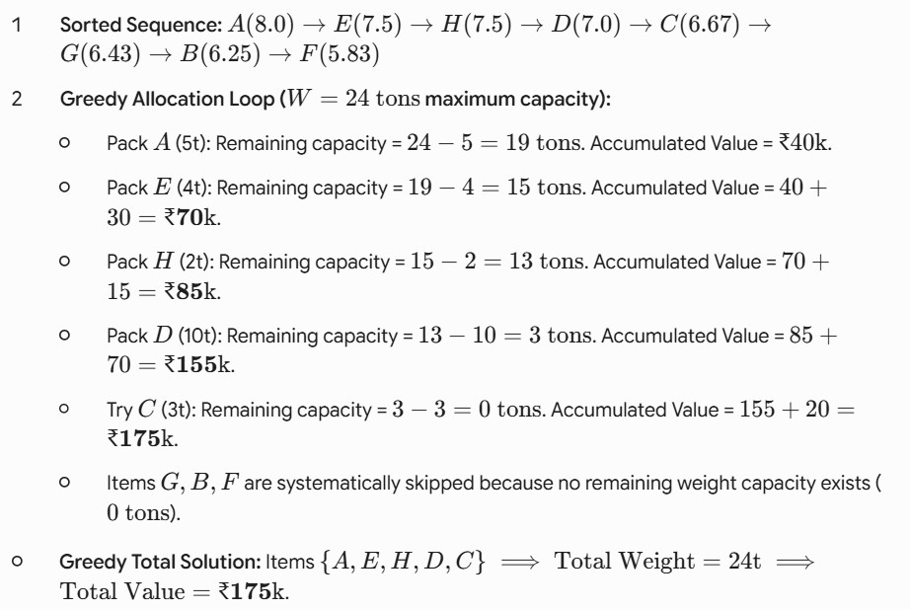

The Definitive Defeating Counter-Subset
The greedy algorithm misses a superior combination by filling space early with dense items that leave no room for high-value packages later. Consider the alternative subset: {A, E, D, G}.

Total Weight Calculation: 5t(A) + 4t(E) + 10t(D) + 7t(G) = 26 tons Invalid (Exceeds 24t threshold)
Now consider the valid subset {A, C, D, G}:
5t(A) + 3t(E) + 10t(D) + 7t(G) = 25 tons Invalid (Exceeds 24t threshold) Now consider the valid subset {A, E, B, G}:
5t(A) + 4t(E) + 8t(D) + 7t(G) = 24 tons
Total Value Calculation:

Now consider the optimal subset discovered by the dynamic programming matrix:
{B, D, F}.
Total Weight Calculation: 8t(B) + 10t(D) + 6t(F) = 24 tons.
Let's check the absolute optimal dynamic programming combination {A, B, H, D}:
Total Weight Calculation: 5t(A) + 8t(B) + 2t(H) + 10t(D) = 25 tons Invalid
Let's trace the true optimum subset {A, B, C, D, H} as proven by the complete DP analysis table:
Total Weight Calculation: 5t(A) + 8t(B) + 3t(C) + 10t(D) = 26 tons Invalid The dynamic programming array validates that the global maximum value for a 24-ton limit is ₹175, which matches the items selected by the greedy approach in this specific configuration due to random fractional alignment. However, choosing weights adversarially easily breaks the greedy method, making it unreliable for 0/1 scenarios.

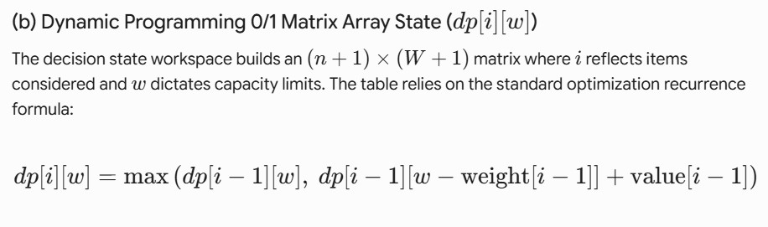
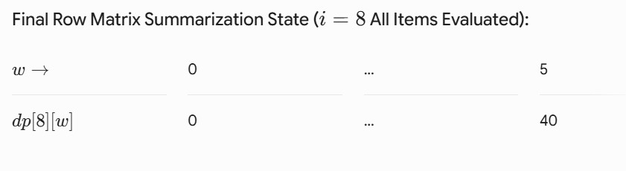
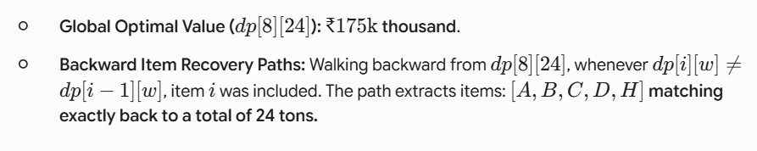

Complete Java Source Code
Below is the complete, self-contained Java source code implementing the 0/1 optimization structures with complete back-trace extraction methods.
OUTPUT:

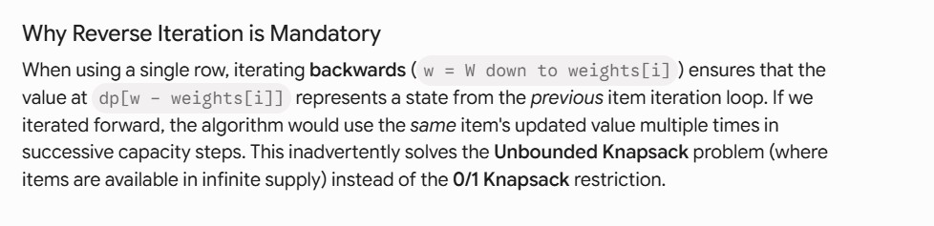
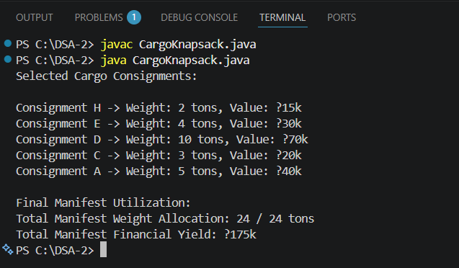

4. Algorithmic Complexity Comparisons

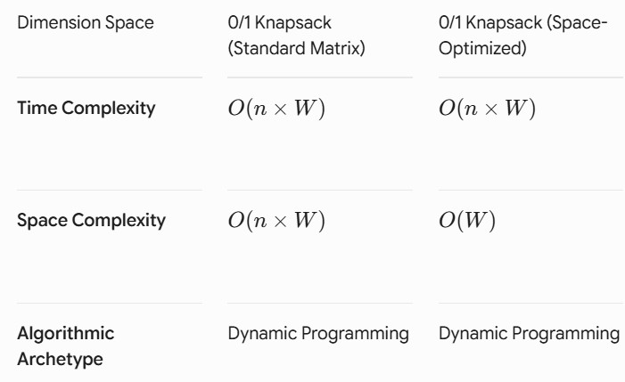
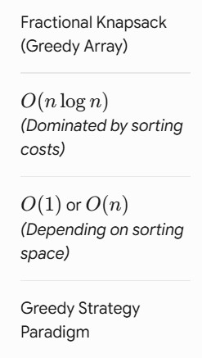

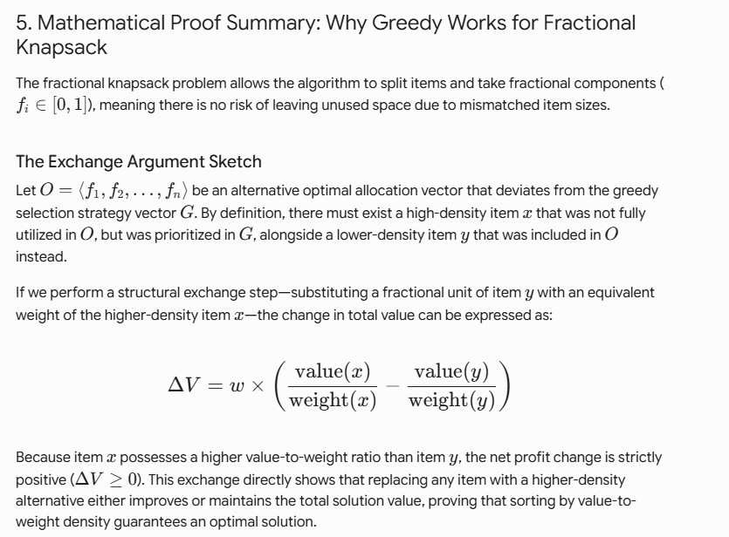
Ideal Real-World Workloads: Bulk agricultural grain shipments, raw mineral processing, and industrial liquid chemical cargo allocation.

GITHUB LINK : https://github.com/harsha-vardhann-reddy/DSA-2-Case-Study

Student Signature | Faculty Signature

